Employee information System
(eGov EIS)

Product Specification Document


eGovernments Foundation
www.egovernments.org
Copyright © 2004 eGovernments Foundation, All Rights Reserved.

Document Version History
Version | Date | Author | Comments
1.0 | 15/1/2017 | Satish N | Product Release
1.1 | 24/01/2017 | Satish N | Reviewed by Elzan for Phase 1 requirements.

Legal Disclaimer
eGovernments Foundation its members, officers, directors, employees, or agents shall not be liable for any injury, loss, damages, financial or otherwise, arising from, related to, or caused by the use of this document or the specifications herein, as well as associated guidelines and schema. The use of said specifications shall constitute your express consent to the foregoing exculpation.
Copyright
eGovernments Foundation. All rights reserved. No part of this publication may be reproduced, stored in a retrieval system, or transmitted, in any form or by any means, electronic, mechanical, photocopying, recording, or otherwise, without the prior written permission of the publisher.
Trademarks
eGovernments Foundation and eGovernments Foundation logo are trademarks or registered trademarks of "eGovernments Foundation," a non-profit organisation. All other product names and company logos mentioned herein are the trademarks of their respective owners. In the best effort, all terms mentioned in this document that are known to be trademarks or registered trademarks have been appropriately recognised in the first occurrence of the term.

Table of Contents

Table of Contents 2
1 Introduction 3
1.1 Overview 3
1.2 Abbreviations/Definitions 3
1.3 Assumptions 4
2 Product Road map 4
2.1 Integration with other eGov products 5
3 System Overview 5
4 Master 5
4.1 General Master 5
4.1.1 Employee Group 5
4.1.2 Language 5
4.1.3 Religion 5
4.1.4 Community 5
4.1.5 Category 5
4.1.6 Recruitment Mode 6
4.1.7 Recruitment Type 6
4.1.8 Recruitment Quota 6
4.1.9 Grade 6
4.1.10 Employee Type 6
4.2 Designation and Position setup 6
4.2.1 Designation Master 6
4.3 Calendar Setup 7
4.4 Calendar Holidays Setup 7
4.5 Leave Masters Setup 9
4.5.1 Leave Type 9
4.5.2 Leave Allocation 10
4.5.3 Manage leave opening balances 10
5 Employee Master 11
6 Attendance recording 15
7 Leave Application 18
7.1 Apply Leave 18
7.2 Compensatory Leave 22
8 reports 24
8.1 Employee History 24
8.2 Attendance Report 29
8.3 Employees Leave Report 30
8.4 Employee Leave Summary Report 31
8.5 Employee without assignments 33

Introduction

Overview

Personnel Management is one of the most important and critical functions in any government department. EGov EIS aims to create a single, organisation-wide standard database of employee data and subsequently, automate and streamline all the processes related to effective personnel management. EGov EIS includes the below modules

  - Master Data Management
    - Employee Master (Personal, Educational, technical Skills)
    - Definition of an assignment with designation, position and financials attributes.
    - Nominees for various allowances
    - Calendar setup
    - Leaves types
    - General Masters (Grade, Category, Community, Religion, Mode, Languages)
    - Designation
    - Position master

  - Leave Management
    - Types of Leaves maintenance
    - Designation to Leave mapping
    - Leave Application and approval work flow

  - Attendance Management
    - Day wise attendance
    - Comp off application and approval

  - Management of Disciplinary Actions
    - Create disciplinary action
    - Approve disciplinary action for exception

  - Reports
    - Employee History
    - Attendance
    - Employee Leave report
    - Leave summary
    - Employee without assignment

Abbreviations/Definitions

Term | Definition
HOD | Head of Department
THL | Two Half Leave
HP | Half Present
HL | Half Leave
OT | Over time. An holiday worked can be marked as OT to indicate an extra payment instead of a comp off
H | Holiday
CE | Comp off Eligible
C | Comp off given for working on a holiday. An Holiday can be marked as P and another working can be marked as C to indicate it as a comp off
Positions | Number of approved work force for a designation

Assumptions

It is assumed that all employees in the corporation are mapped to positions derived from the organisation structure.

Product Road map

Release | Feature | Description
1.0 | Employee | - Employee Master with following details -  - General details  - Assignment  - Jurisdiction  - Educational qualification  - Technical qualification  - Departmental Tests Passed  - Probation  - Regularization  - Service history  - Movable Properties  - Immovable Properties
1.0 | Masters | - Calendar Setup  - Language  - Religion  - Community  - Grade  - Employee Type  - Employee Group  - Employee Category  - Recruitment Mode  - Recruitment Type  - Recruitment Quota  - Designation  - Position  - Holiday  - Calendar setup  - Nominee
1.0 | Leave | - Type of Leaves  - Designation to Leave mapping  - Maintain leave opening balance for employees(Manual)  - Leave Application and approval  - Compensatory Leave – apply and approve
1.0 | Attendance | - Day wise attendance marking
1.1 | Disciplinary Action | - Create disciplinary action  - Approve disciplinary action for exception pay slip
1.0 | Reports | - Employee History  - Attendance  - Leave report  - Leave Summary report  - Employee Status Report  - Employee Assignment Report
1.0 | Employee Self Service | - Apply Leave  - Apply compensatory leave

Integration with other eGov products

eGov EIS integrates with eGov Infrastructure for
- Security and Authentication
- Workflow handling

All other eGov products use eGov EIS for employee authentication.

System Overview

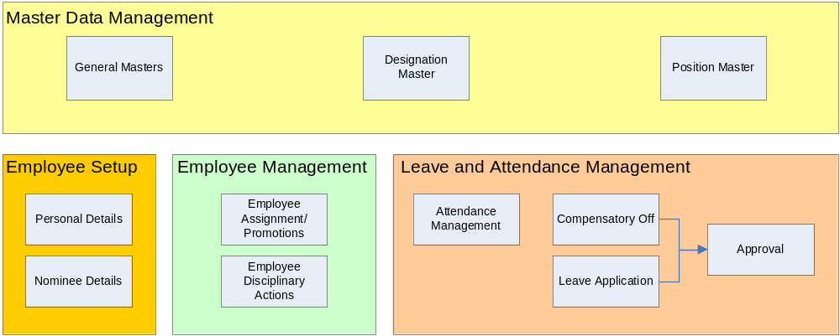

Master

General Master

Below is the list of general masters used in creation of Employee -

Employee Group

Language

Religion

Community

Category

Recruitment Mode

Recruitment Type

Recruitment Quota

Grade

4.1.10 Employee Type

Designation and Position setup

- Each Employee must be assigned to a position under the designation and department.
- The total number of position defined under a department and designation is considered as the total sanctioned post.
- A position uniquely identifies an employee. Position represents the individual employee and only one employee is mapped to a position for a given date range.

Designation Master

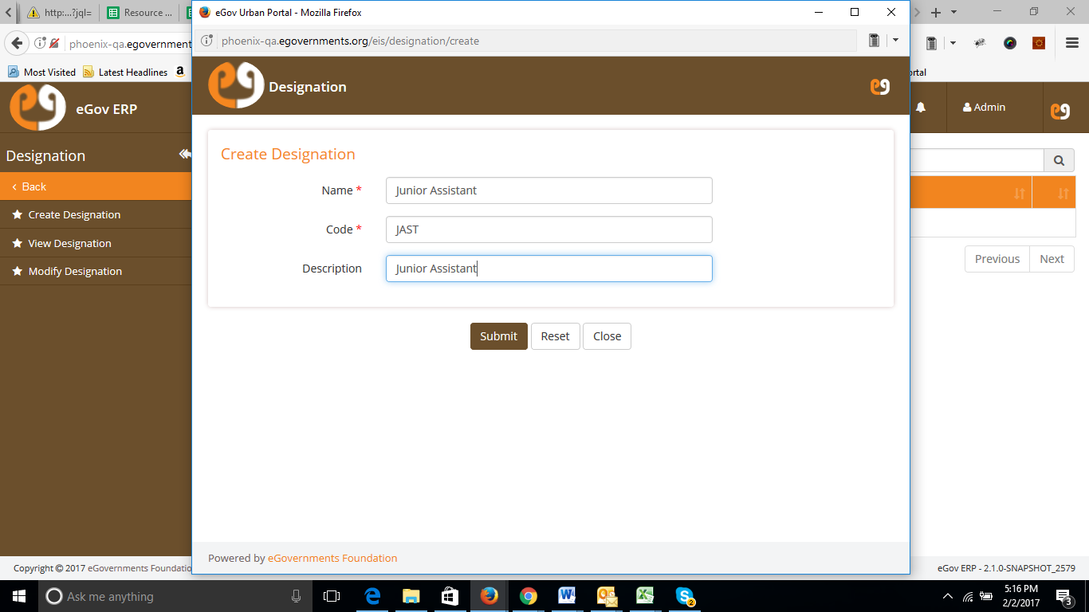

Field | Field Type | Required (Y/N) | Comments
Name | Text | Y | Name for the designation. Default with Capital letters
Code | Text | Y | Internal Description for reference.
Description | Select List | Y | Formal description for Designation.

Position Master 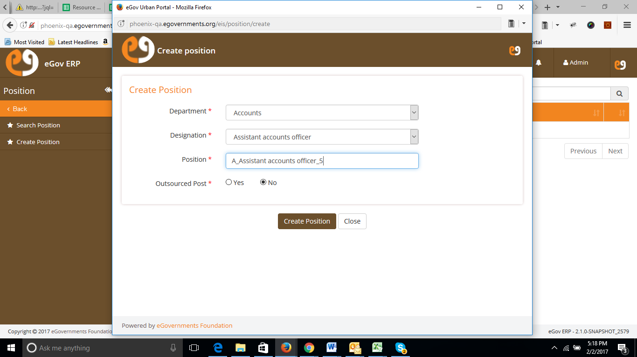

Field | Field Type | Required (Y/N) | Comments
Department | Select list | Y | List of Department from master
Designation | Select list/Auto complete | Y | List of designation from master
Position | Auto populated  The format for position name generation is - <Dept Code>_<Designation Name>_<Running sequence Number> | Y | The running sequence position under the selected department and designation.  This should not be allowed to edit in modify position screen.
Outsourced post | Radio Button | Y | With option Yes / No. For MIS to

Calendar Setup

The calendar year setup needs to be configured to mark attendance and handle leave requirements.

Field | Field Type | Required (Y/N) | Comments
Year | Numeric (4 Digits) | Y | Definition of calendar year. The 4 digit year entered should be unique.
From Date | Text | Y | The date from which the year is starting
To Date | Text | Y | The last date till which the year is defined
Active | Check box | Y | If this year is to be made active or not. By default, it should be marked as active on create.

Calendar Holidays Setup

The Governments holidays and restricted holidays need to be defined for attendance and leave module to consume the holidays defined appropriately. The holiday setup will cover the following:

The fig is just the sample of existing screen, (To be treated as a wireframe)
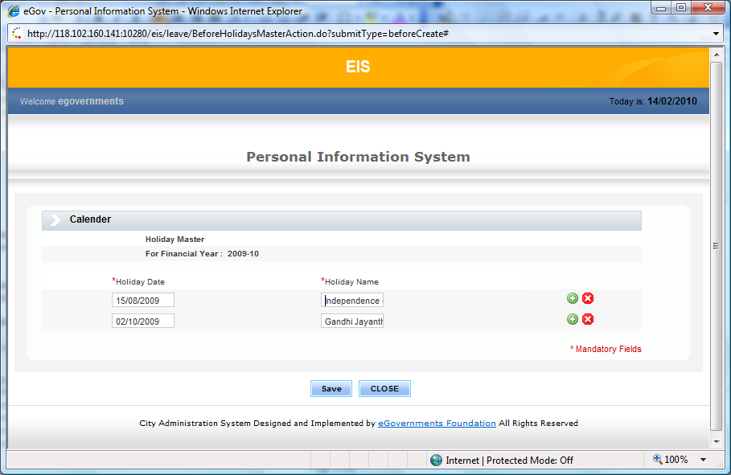

Field | Field Type | Required (Y/N) | Comments
Calendar Year | Select List | Y | List of Calendar year from master. Sort the year in descending order
Details screen (Shown as the calendar year is selected)
Holiday Date | Date | Y | Date of the holiday
Holiday Name | Text | Y | Name given for the holiday

Leave Masters Setup

Leave setup includes:
- Leave types definition
- Designation to leave mapping (Number of Leave definition)
- Creating/updating opening balances for each employee

Leave Type

The leave types master will capture the nature of the leave with its code. Allows to define if a leave type is accumulated (Carry forwarded) and if it is of type half leave.

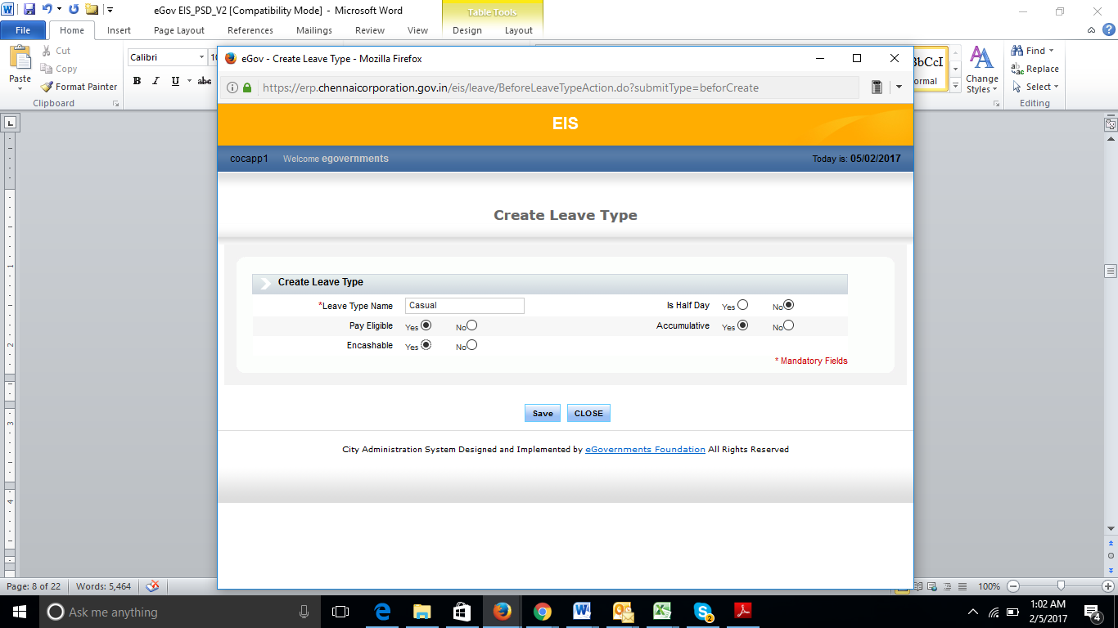

Field | Field Type | Required | Validation/Comments
Leave Type Name | Text | Y | Name of the leave type such as medical, personal
Is Half Day | Radio Button | Y | To indicate if the leave created is of type “half day”. This type of leave allows user to apply half day leave and also has an option to apply for 2 half day for a day leave.
Pay eligible | Radio Button | Y | Indicates if the leave type created is eligible for pay or not. This decides if the salary has to be deducted for this kind of leave.
En-cashable | Radio Button | Y | Indicates if the leave can be encashed.
Accumulative | Radio Button | Y | Indicates if the leave type is accumulative or unused days in employees account expire on closure of the year.

The following types of leaves can be defined –
- Is Half Day – This type of leave will be considered as half day and leave application gives an option to apply 2 such leaves in place of a day’s leave.
- Pay eligible – This flag indicates if the leave is eligible for pay or just as unpaid leave. Approved study leaves or unpaid long leave types can be defined using this flag, pay eligible as ‘N’.
- Accumulative – This flag defines if the leave can be accumulated and carry forwarded.
- En-cashable – This flag indicates that the leave type can be encashed.

Leave Allocation

Number of days for every leave types may vary based on the designation. The screen provides the mapping of leave types and number of days eligible for each designation.
- System is configurable to have same number of leave days leave type wise for all designations.
- System is configurable to have different number of leave days leave type wise for each designations.
- As product, system will have to capture leaves irrespective of designation.
- In case of designation wise leave, system should provide option to enter the leave days commonly for all designation and then specifically for a single designation.

Refer the below screen for Leave days Set up-

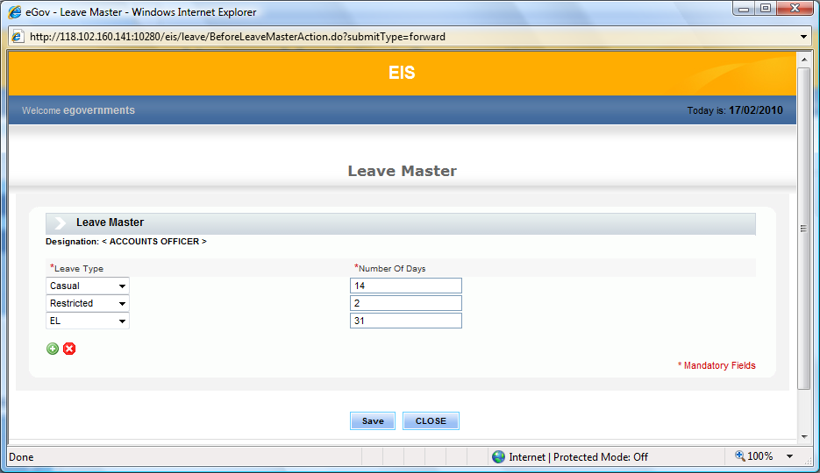
Field | Field Type | Required (Y/N) | Comments
Designation | Select List | N | Designation master list. If designation is selected, then the leave days will be associated with only that designation.
Leave Type | Select List | Y | Leave type master list
Number of Days | Number | Y

Manage leave opening balances

All accumulative type leaves can be carry forwarded to the next calendar year. Based on the leave opening balances as of the current year and the leaves approved for the current year, one can calculate the remaining number for leaves eligible for each leave type that are of accumulative type. This balance will be considred as the leave opening balance for the next calendar year.
- Leave opening balances will be based on calendar year.
- Employees can be retrieved based on multiple search criteria for updating the opening balances of leave. Search criteria include designation, department, and employee code. User can search based on any of these parameters or using multiple parameters. On selecting these parameters and submitting, the list of employees based on the criteria is displayed for updating the number of days for the selected leave type and calendar year.
- Setup would allow creating opening balances for only leave types that are set as accumulative.
- User will be able to search for employees by code, department, designation (one or more of the criteria) and update opening balances of a leave type for calendar year.
- If opening balances already exist for employees, the screen will show the existing values. User can modify and save these values.
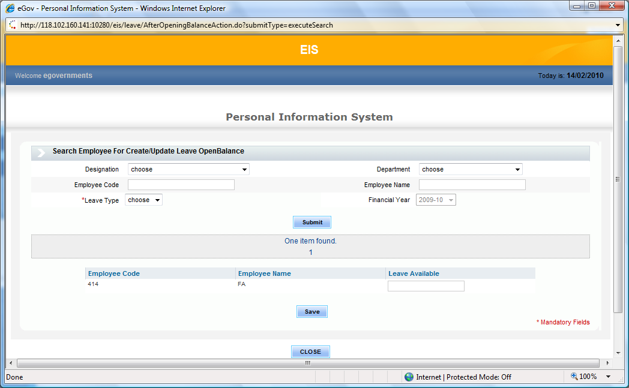

Field | Field Type | Required (Y/N) | Comments
Designation | Select List | N | Designation master list
Department | Select List | N | Department Master list
Employee Type | Select list | N | List of employee types defined.
Employee Code | Text | N | Select employee code from the list (auto populated as the initial characters are typed – can be searched by code, name and position)
Employee Name | Display | N | Populate based on employee code selected.
Leave Type | Select List | Y | Leave Types master list
Calendar Year | Date | Y | Defaulted to current year
On Search, the detail screen displays as below -
Employee Code | Display | - | Employee code based on the search criteria
Employee Name | Display | - | Employee name corresponding to the code
Leave Available | Numeric | y | User entry

Employee Master
Maintenance of Employee Master will include
- Personal Details – All personal information, address and Bank Account details (For Salary Credit).
- Employment Details – Date of appointment, retirement, Grade and Recruitment process (MIS Information). Each Employee is assigned a Role-based user name, which is used for logging into the system and to decide the menu options accessibility.
- Assignments details - Each employee should be mapped to Fund, Function, Position and Designation which is valid for a date range. Position determines his role in work flows and process like Advance approval, Pay slip approval, Leave approval, etc.,
- Service Details – All the service related updates are recorded in this section. This will be manually updated information (Optional) maintained for each employee. This information can be used for generating reports.
- Education and technical skills –This section records education details, technical skills, and department test taken by the employee. These details are maintained for information and should be manually updated. This information is optional and can be updated at any point of time at later stages.

Field | Field Type | Required(Y/N) | Comments
Status | Select List | Y | List with options - Employed, Retired, Resigned, Terminated, Deceased, Suspended, Transferred.
Employee Type | Select List | Y | List with options - Permanent, Temporary, Daily Wages, Contract, Deputation
Employee Code | Text field (user Entry) | Y | Automatically generated or manually entered for a new employee based on the configuration. This field will be shown only if the setup is done for manual generation of employee code. The format for auto generation should be configurable. Default configuraton is Manual entry for the employee code. The default format for employee code is 5 digit running sequence number. Ex - 00156
Employee Group | Select list | N | List of employee group from master – State, Central , Local
Date Of Birth | Date | Y | Should be greater than 15 years of age. (Should be 15 years prior from current date)
Employee Name | Text (Alpha) | Y | Employee Full name
Gender | Select Box / Radio Button | Y | With Option/Values : Male, Female, Others
Marital Status | Select list | Y | List of status – Married, Unmarried, Divorced, Widower, Widow
Father’s/Husbands Name | Text | N | Father’s/Husband full name
Native/Birth Place | Text | N | Name of City-District
Blood Group | Select Box | N | From standard list -  O-  O+  A-  A+  B-  B+  AB-  AB+
Mother Tongue | Select Box | N | From language Masters list
Religion | Select Box | N | From religion Masters list
Community | Select Box | N | From community Masters
Category | Select Box | N | From list of employee category
Is Physically Handicapped? | Check box | N | Mark as yes if handicap.
Is Medical Report Available? | Check box | N | Mark as yes if report available
Identification Mark | Text Box | N | Identification mark of employee for information
PAN | Text Box (10 Characters) | N | PAN number for information
Passport Number | Text Box (10 Characters) | N | Passport number of employee for information
GPF Number | Text Box | N | GPF Number for Info and PF processing
Aadhaar Number | Text Box (16 Digits) | N | Aadhaar number for information
Bank | Select list | N | List of bank from master.
Branch | Select list | N | List of Branch under selected bank. Branch will have IFSC code details too.
Account number | Numeric (upto 16 digits) | N | Bank account number of employee for salary credits.
eMail ID | Alpha Numeric | N | Email id of employee
Phone number | Numeric 10 digits | Y | Mobile number of the employee
Phone Number (Emergency/Res) | Numeric | N | Residential or emergency contact number
Permanent Address | Textarea | Y | Address of employee for information
City | Text Box | Y | City data for Address
Pin code | Numeric (6 digits) | Y | Pin code for specified Address
Correspondence Address | Textarea | N | For information
City | Text Box | N | City data for Address
Pin code | Numeric (6 digits) | N | Pin code for specified Address
Languages Known | List Box | N | Language from master, with multiple selection
Local Language Qualified | Select Box | N | From language master
Recruitment Mode | Select Box | N | List from Master – UPSC, Department Exams, Direct
Recruitment Type | Select Box | N | List from master – Direct, Transfer, Compensatory
Recruitment Quota | Select Box | N | List from Master – Sports Quota, Ex-Serviceman, Handicapped, Others
Date of Appointment | Date | Y | Date used for validation in updating assignment details and in generating various reports.
Date of Joining/Deputation | Date | N | Defaulted with date of appointment initially(First time)
Retirement Age | Numeric | N | User entry
Retirement Date | Date | N | Automatically populated based on the age entered and editable
Deceased Date | Date | N | Date of death for status “Deceased”
Termination Date | Date | N | Date of termination for status “Terminated”
Resignation Date | Date | N | Resignation date for status “Resigned”
Is user Active | Radio Button | Y | If the employee needs to be an active user of the system, then mark it as active.
User Name | Text Field | Y | User name of the employee with which he/she can log into the application.
Employee Photo | Attachment | N | Image attachment option for uploading employee photo
Employee Signature | Attachment | N | Image attachment option for uploading employee signature
Other Attachments | Attachment | N | Multiple attachment option to upload other supporting documents, forms and applications if any.
Assignments Details section (Multiple rows may be there)
Is Primary | Radio Button | Y | Flag will decide if the record is primary or Temporary assignment. The assignment should be unique for its type for a given date range.
From Date | Date | Y | Start Date for the assignment period
To Date | Date | Y | End date for the assignment period
Fund | Select list | N | From Fund master list
Function | Select List | N | From Function master list
Grade | Select List | N | From Grade master list
Designation | Select List | Y | From Designation list
Position | Select List. | Y | The position is used to determine approval hierarchy in workflows. For example, when a work order is submitted by a Junior Engineer, it is sent for approval to the Assistant Engineer, and then to the Senior Engineer. Since the system is based on position as opposed to individuals, work is not affected when an employee retires or is transferred. NOTE: A single employee can be assigned to a particular position for a specific period. When you try to assign a position that is already assigned to another employee within that time period as a primary assignment, an error message is displayed.
Functionary | Select List | N | Functionary Master Lists
Department | Select List | Y | Department Master list
If HOD | Radio Button | Y | Indicates that employee is the HOD of the selected department for that assignment period
HOD Departments | Multiple Select List box | Y | NOTE: This field is displayed only if the employee is the Head of Department. Shows list of departments for selection.
Govt Order No | Text | N | GO reference number for the change in the assignment.
Attachment | Doc Attachment | N | Document attachment option of file type – PDF, Image, doc for uploading the GO passed.
Jurisdiction (Multiple rows may be there)
Jurisdiction Type | Select list | Y | List of Boundary types
Jurisdiction List | Select list | Y | List of Boundaries for selected type
Service details Section (Multiple rows may be there)
Service Details/history/ledger
Serial no | Numeric | Y | Running sequence
Service Entry Description | Text | Y | The description of service changes
Service From | Date | Y | Date on which the changes were done
Remarks | Textarea | Y | Reason for change
Order No | Text | Y | Order number passed for the changes
Doc Attachment | Attachment | N | Document attachment option of file type – PDF, Image, doc for uploading the GO passed.
Probation
In which post | List box | Y | From Designation list
Probation Declared date | Date | Y | Date on which the probation was initiated
Order no | Text (Alphanumeric) | N | The GO number corresponding to the probation
Order Date | Date | N | Order date
Doc Attachment | Attachment | N | Document attachment option of file type – PDF, Image, doc for uploading the GO passed.
Remarks | Textarea | N | Any general remarks
Regularisation
In which post | List box | Y | From Designation list
Probation Declared date | Date | Y | Date on which the probation was initiated
Order no | Text (Alphanumeric) | N | The GO number corresponding to the probation
Order Date | Date | N | Order date
Remarks | Textarea | N | Any general remarks
Doc Attachment | Attachment | N | Document attachment option of file type – PDF, Image, doc for uploading the GO passed.
Other Details (Multiple rows may be there)
Educational Qualification
Qualification | Text | Y | The qualification completed
Major Subject | Text | N | Description of Major subjects qualified in.
Year of Completion | Drop down | Y | Calendar year
University/Board | Text | Y | Board from which the certification was issued
Doc Attachment | Attachment | N | Document attachment option of file type – PDF, Image, doc for uploading the GO passed.
Remarks | Textarea | N | Any general remarks
Technical Qualification
Skills | Text | Y | Skills certified for.
Grade | Text | Y | Grade obtained for Skills certified.
Year of Completion | Drop Down | Y | Calendar year
Remarks | Textarea | N | Any general remarks
Doc Attachment | Attachment | N | Document attachment option of file type – PDF, Image, doc for uploading the GO passed.
Departmental Test Details
Name of the Test | Text | Y | Name of the Departmental Test cleared.
Year of Completion | Drop Down | Y | Calendar year
Doc Attachment | Attachment | N | Document attachment option of file type – PDF, Image, doc for uploading the GO passed.
Remarks | Textarea | N | Details pertaining to test cleared

Attendance recording
- A daily attendance matrix will be shown for marking the attendance. For recording attendance, employees can be searched based on one or more parameters - Employee Code or Name, Department, Month, Calendar Year and Designation. Depending upon the search parameters, one or more employee records are displayed in the attendance matrix.
- For each day, user can mark ‘P’ or ‘A’ or ‘HP or ‘OT’’ to record attendance for an employee.
- The regular holidays (Sundays, 2nd Saturdays etc) as well as public holidays will be shown in different colors.
- Work Week Definition can be configured with the following options: (Configurable parameter)
- 5-day week
- 6-day week
- 5-day week with 2nd Saturday holiday
- 5-day week with 2nd and 4th Saturday holiday
- The user will be able to record attendance for individuals on holidays as well. This will give an option to opt for a comp-off for the day worked.
- For each employee, the following data is computed at the end of every month and shown as part of the attendance summary:
  - Total Present Days
  - Total Absent Days
  - Sanctioned Leave
  - No. of Pay days = Total Present Days + Compensatory Offs+ OT – Total Absent Days + Sanctioned Leave – Unpaid Leave
- Compensatory Offs are eligible for pay. It is treated as approved leave
- A holiday can also be marked as OT which can be paid along with salary instead of providing a comp off to the employee.
- Leaves applied will be shown in display mode accordingly
  - L – Any type of Leave applied ( and the type is not HL – Half Leave)
  - THL – Two half leave (If 2 half leave type is applied for one day leave)
  - HL – Half leave (if a half leave type is applied)
  - C- Comp off
- If user is marked P on a holiday, the system will show an alert message – “User will be eligible for a compensatory off if working on holiday. Do you wish to continue?” On clicking Yes, the user’s list of working days eligible for comp off will be updated and once approved user’s is available comp-offs are updated.
- On any day (that is not already been marked holiday), a compensatory off can be marked by applying a comp-off. Validation will be done that the user has worked on a holiday within the period that has been approved as eligible for comp-off

Attendance search will look like below

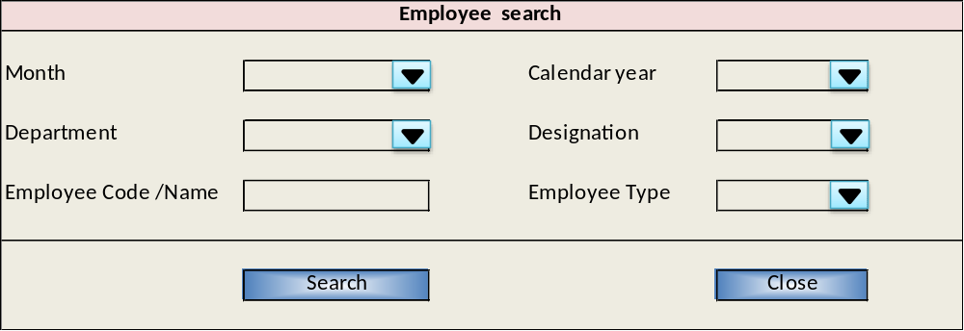

Field | Field Type | Required (Y/N) | Comments
Department | Select List | N | From Department master
Employee Type | Select List | N | List of Employee Type configured.
Employee Code/Name | Text | N | User entry employee code or Name
Month | Select List | Y | List of calendar month. Month for which the attendance is marked
Year | Select List | Y | From Calendar year list.
Designation | Select List | N | List of designation from masters

On Search the below detail screen is shown for marking attendance. Any one of the search criteria is mandatory over and above month and year.

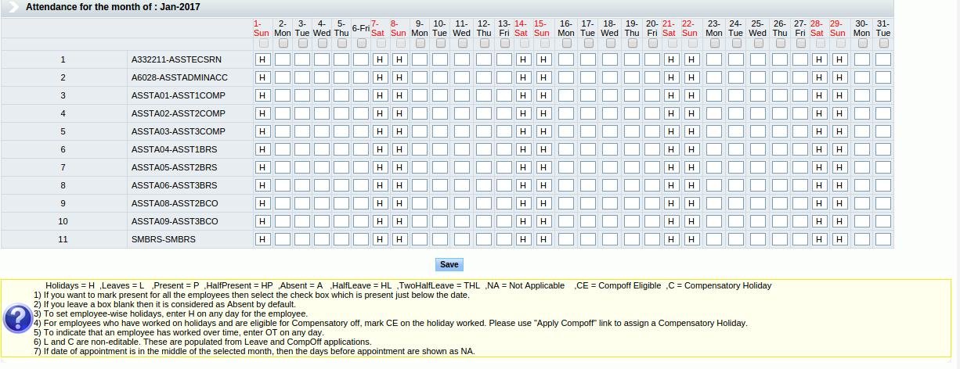

Field | Field Type | Required (Y/N) | Comments
Header row for all days in the month | Check box | NA | To mark ‘P” for all the employees selected in the screen for the particular day.
Detail rows for every employee for all the days of the month | Text | NA | To Mark attendance individually for each day. Allows ‘P’, ‘A’, ‘HP’ and ‘OT’ in case of holiday.

- System will list the employees who have primary assignment for the selected month and year.
- If department is selected in search criteria, show only the employees who have primary assignment in that selected department as on the attendance month (last date of the month) and year.
- If the attendance month is current month, then check the assignment as on current date.
- If an employee has worked under two departments in a month then the latest assignment department will be considered.
- Show all the days for the month and year selected up to the current date. System should not allow to mark future attendance.
- If an employee joined in middle of the month then his attendance will start from his date of Joining and previous days in that month will be marked as 'NA'.
- If an employee is retired/deceased/Terminated in middle of a month, then attendance for that person should be marked only till that date and all days post to that will be shown as 'NA'.
- All holidays and weekly holidays will be marked as 'H' by default when showing the data in the attendance screen.
- Approved Leave days are also shown appropriately.
  - L – Any type of Leave applied ( and the type is not HL – Half Leave)
  - THL – Two half leave (If 2 half leave type is applied for one day leave)
  - HL – Half leave (if a half leave type is applied)
  - C- Compensatory leave
- System should allow to mark attendance for multiple employees one shot.
- On Save, records will be saved in the system and next time the attendance is opened for an employee for the same month and year, all marked attendance should be displayed.

Leave Application

Leave Application has two sections –
- Apply Leave – This feature is used to apply leave for an employee for any day. Based on the eligible leave balance, approver can decide on whether to sanction the leave or not. Approval of leave can be configurable.
- Apply Compensatory Leave – The holidays worked i.e. attendance marked as ‘P’ on a holiday allows the employee to take a compensatory off on any other working day. The validity of this compensatory leave can be configurable, i.e. if it is set to 3 months, then the comp-off for respective working day (on a holiday) should be availed within the 3 months from that day.

Apply Leave

    - Leaves are calculated based on calendar year. The opening balance will be considered from January month onwards. Leaves for a specific year (excluding the opening balances) will be calculated on a prorate basis.
    - This option needs to be provided to every employee as part of employee self service and also to the administrative staff.
    - The configuration setup can be done to include enclosed holiday while calculating number of working days in the applied leaves. If this flag is on, then the holidays in the date range of leave applied will be considered as working day and leaves for the employee is deducted accordingly.
    - If an employee is applying leave, then he will be able to apply for himself alone. Hence the search search is not required, directly the Leave application screen will be opened.
    - Leave application screen provides search employee option based on criteria given below. (applicable for administrative staff)
      - Department
      - Designation
      - Employee Code/Name
      - Employee Type

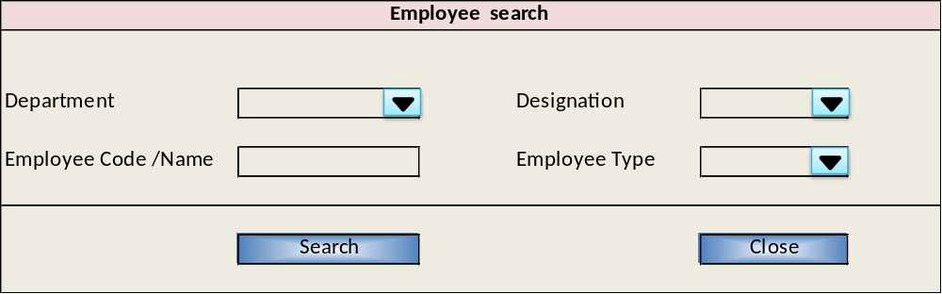

Field | Field Type | Required (Y/N) | Comments
Designation | Select List | N | From Designation master
Department | Select List | N | From Department master
Employee Code/Name | Text | N | User entry to select employee code from the list (auto populated as the initial characters are typed – It can be searched by code, name). When only employee is selected, the employee is listed irrespective of assignment.
Type | Select List | N | From Type master – search will list employees with selected type

- Any one search criteria is to be selected mandatory.
- On Search, a list will shows the below information of all the employees with valid primary assignments as on current date for the given criteria.
- Employee Code
- Employee Name
- Designation
- Department

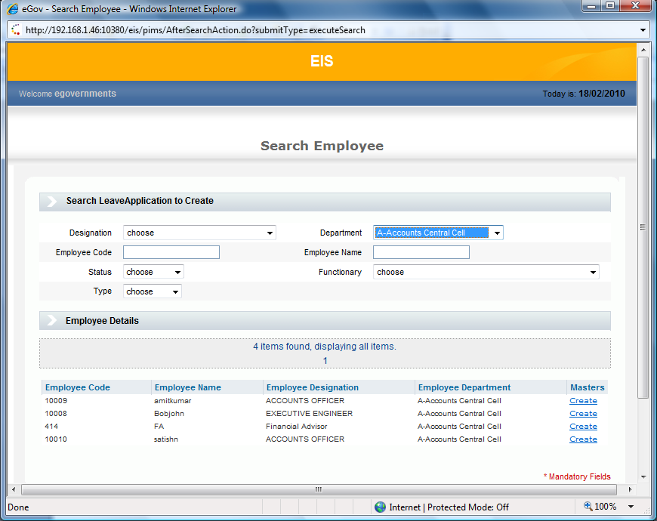

Field | Field Type | Required (Y/N) | Comments
Employee Code | Display | Y | Employee code
Employee Name | Display | Y | Name of the employee
Designation | Display | Y | Designation name for which the employee has current primary assignment.
Department | Display | Y | Department name for which the employee has current primary assignment.

- Provide an option to apply leave.
- On apply leave the below screen will be opened.

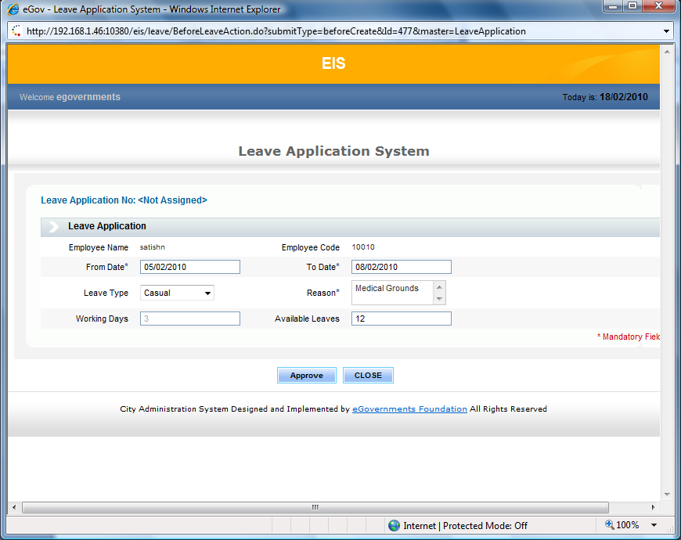

Field | Field Type | Required (Y/N) | Comments
Employee Name | Display | Y | Name of employee selected for entering the leave details
Employee Code | Display | Y | Employee code
From date | Date | Y | Date from which the leave is applied
To Date | Date | Y | Date up to which the leave is applied
Leave type | Select List | Y | Show all the leave types that are applicable to this employee. This can be read from the leave allocation master.
Reason | Text area | Y | The reason for leave application (for records)
Working Days | Display | Y | Displays the actual number of working days between the dates ranges selected for leave application. Excludes holiday while calculating the working days based on how the system is configured.
Available leave | Display | Y | Displays available number of leave for the employee for the selected leave type. The number of available leaves is shown based the date for which leave is applied. It considers employee's designation as of leave applicable from date, to take the eligible number of days and then calculates number of days available, pro rated as of the date on which leave is applied. Any leave opening balances will not be prorated.
Approve/Forward | Button | NA | Creates leave in approved state or allows user to select the next level approval authority. Depends on the workflow set for leave application.
Close | Button | NA | To close the screen

The Leave Application process – For the selected employee, details of leave applied is entered in the following screen.
- Leave application will be created and send to HOD for approval. HOD will get this record in his inbox which will be either rejected or approved.
- SMS will be send to the employee when leave approval or rejection happens based on the system configuration.
- Leave cannot be applied for a date range for which there is already a leave applied for any of the dates in the range.
- The date range applied should be less than the retirement date and greater than the Appointment date.
- If available days are lesser than the applied days, then the difference number of days is considered as unpaid leaves.
- On creating a leave record a Leave application number will be generated which will be shown in the View page.
- Leave application number format will be <5 digit running number>-<2 digit of month>-<4 digit of year>. An example is 15490-10-2016.

Compensatory Leave

- The compensatory leave will be applicable for an employee only if the attendance is marked as ‘P’ for a holiday.
    - This option needs to be provided to every employee as part of employee self service and also to the administrative staff.
- For administrative staff compensatory leave can be searched based on any of the below criteria –
- Designation
- Department
- Employee Code
- Employee name
- Employee Type

- Any one search criteria is to be selected mandatory.

Field | Field Type | Required (Y/N) | Comments
Department | Select List | N | From Department master
Designation | Select List | N | From Designation master
Employee Code | Text | N | User entry to select employee code from the list (auto populated as the initial characters are typed – It can be searched by code, name and position). When only employee is selected, the employee is listed irrespective of assignment.
Employee Name | Display | N | Show employee name for searching based on code selected
Employee Type | Select List | N | From Type master – search will list employees with selected type

- Based on the search criteria, the output screen will display the list of employees date wise who has compensatory leave pending, provided it is within the validity range defined in the setup.
- Each employee's date should be shown together arranged by worked date in ascending order.
- The worked date should be less than the retirement date and greater than the Appointment date.
- Below screen will be shown on search-

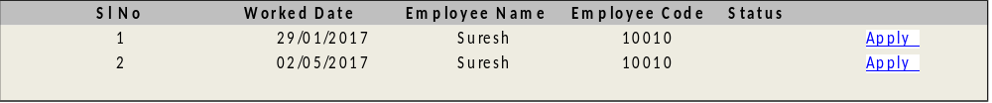
- When an employee applies for compensatory leave from the employee self service option, the link should open directly to the above screen, when the employee himself can apply compensatory leave for any day that he is eligible for.

Field | Field Type | Required (Y/N) | Comments
Serial Number | Display | Y | Running serial number
worked holiday date | Display | Y | Eligible holiday date on which the employee has worked.
Employee Code | Display | Y | Name of the employee.
Employee Name | Display | Y | Corresponding Employee Name
Status | Display | Y | Status of the compensatory leave

- Provide an option to apply for compensatory leave for any employee for any date. System should not allow to select multiple records at a time applying for leave.

Apply for compensatory leave
- Compensatory Leave application screen will look like below-
- Employee Name
- Employee Code
- worked on
- Compensatory Leave on
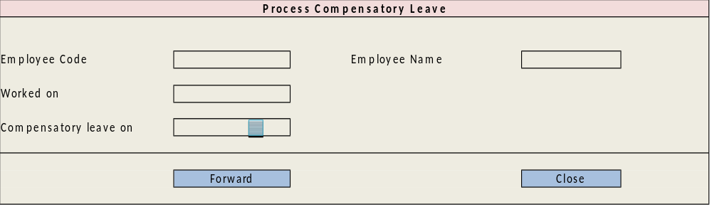

Field | Field Type | Required (Y/N) | Comments
Employee Name | Display | Y | Name of the employee.
Employee Code | Display | Y | Corresponding Employee Code
Worked on date | Display | Y | Date of holiday on which employee has worked
Compensatory Leave on | Date | Y | User entry. Date on which the comp-off is to be availed. It Should be within the appointment date and retirement date. Comp-off cannot be applied on a holiday or on a day where leave is applied.

- Once details are entered, leave application number will be generated and the same will be send for approval based on the work flow configured.
- Application will be send to the HOD of the department to which the employee belongs to.
- Approve can either approve or reject the application. If the record is approved then the leave status changes to “Approved” and if the leave application is rejected, the status changes to “Rejected”.
- Once the leave is approved, this will be reflected in the attendance accordingly.
- Once the leave is rejected, it will end the work flow and the same leave record will show as rejected. There will be no impact on attendance. Employee can re-apply for the rejected leave once again.

reports

Employee History
Employee history displays all the assignments details of the employee selected based on a criteria. The report search screen allows user to search employee based on any (one or more) of the below criteria
- Department
- Designation
- Employee Code/Name
- Type
- Status

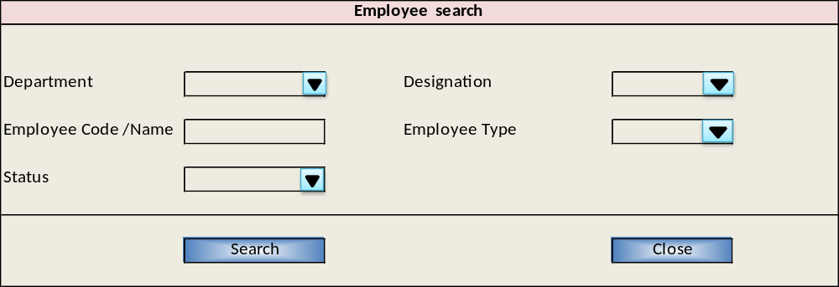

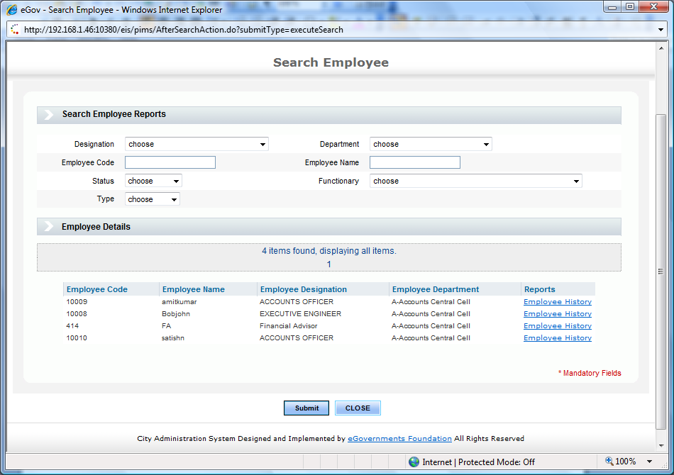

Field | Field Type | Required (Y/N) | Comments
Department | Select List | N | From Department master
Designation | Select List | N | From Designation master
Employee Code/Name | Text | N | User entry to select employee code from the list (auto populated as the initial characters are typed – It can be searched by code, name ). When only employee is selected, the employee is listed irrespective of assignment.
Status | Select List | N | From Status master – search will list employees with selected status
Type | Select List | N | From Type master – search will list employees with selected type
Employee Details
Employee Code | Display | Y | Employee codes based on the search criteria
Employee Name | Display | Y | Employee name corresponding to the code
Designation | Display | Y | Employee’s Designation
Department | Display | Y | Employee’s Department
 | Hyper Link from “Employee History” | Y | On click, the employee assignments history details are shown in the report
Provide a drill down from the employee code to view employee screen.

The employee Assignment history report

System should the complete assignment details of the employee irrespective of primary and temporary assignment. Data needs to be sorted on assignment from date.

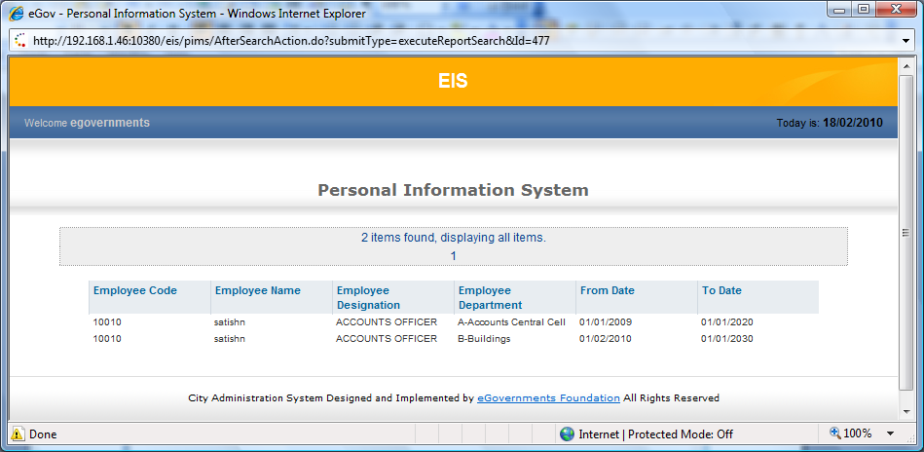

Field | Field Type | Required (Y/N) | Comments
Employee Code | Display | Y | Employee code.
Employee Name | Display | Y | Corresponding employee name
Designation | Display | Y | Employee’s Designation
Department | Display | Y | Employee’s Department
Primary | Display | Y | Yes in case of Primary assignment and No is case of temporary.
From Date | Display | Y | Starting Date for the assignment
To Date | Display | Y | Ending date for the assignment

Attendance Report

The attendance report shows all the information about the attendance for a given month for multiple employees based on any of the search criteria given below
- Month
- Calendar Year
- Department
- Designation
- Employee Code/Name
- Employee Type
Apart from month an year any one search criteria is mandatory.
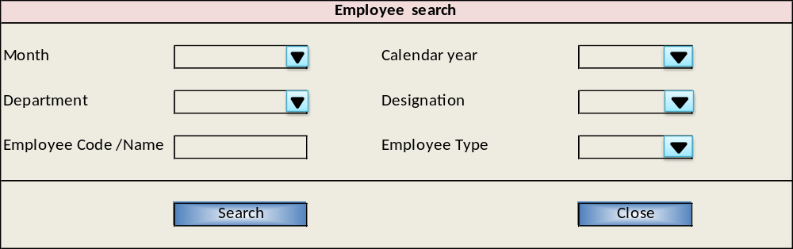

Field | Field Type | Required (Y/N) | Comments
Month | Select List | Y | List of calendar Months
Calendar Year | Select List | Y | From Calendar year Master.
Designation | Select List | N | List of designation name from Designation Master
Department | Select List | N | List of department name from Department master
Employee Code/Name | Text | N | Auto complete of employee code/name
Employee Type | Select List | N | List of employee types

Search result should list all the employees' who match the selected criteria (attendance will be always for primary assignment), along with the attendance data. Employees' from whom attendance is not yet marked for the given month also needs to be listed. If attendance is not marked, it will be treated as Absent.

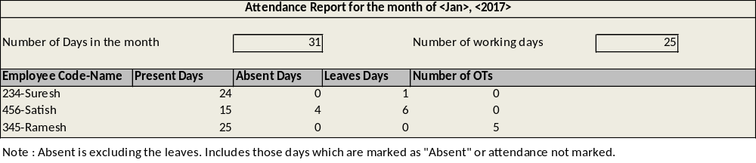

Field | Field Type | Required (Y/N) | Comments
Employee Code-Name | Display | Y | List of Names of the employee for the given criteria sorted by Employee name
Number of days in month | Display | Y | Total number of days in the month
Number of working Days | Display | Y | Total number of working datys in the selected month which will exclude holidays and weekly offs.
Present Days | Display | Y | Total number of present days. Actual presents.
Absent Days | Display | Y | Number of absent days for the employee. The days in attendance marked as ‘A’ . If attendance is not marked for a day, that also will be considered as absent.
Leave days | Display | Y | Total number of approved leaves in that month. This will incude the compensatory leave as well.
No of days Over time | Display | Y | Display number of OT’s worked. All holidays marked as ‘OT’ in attendance

Employees Leave Report

Employees leave report shows all the leave information of the employee selected for a given date range. The search screen allows user to search employee based on the criteria given below. The report will allow user to sort by employee code and application number.
      - Designation
      - Department
      - Employee Code/Name
      - Employee Status
      - Employee Type
      - Leave Type
      - Date Range

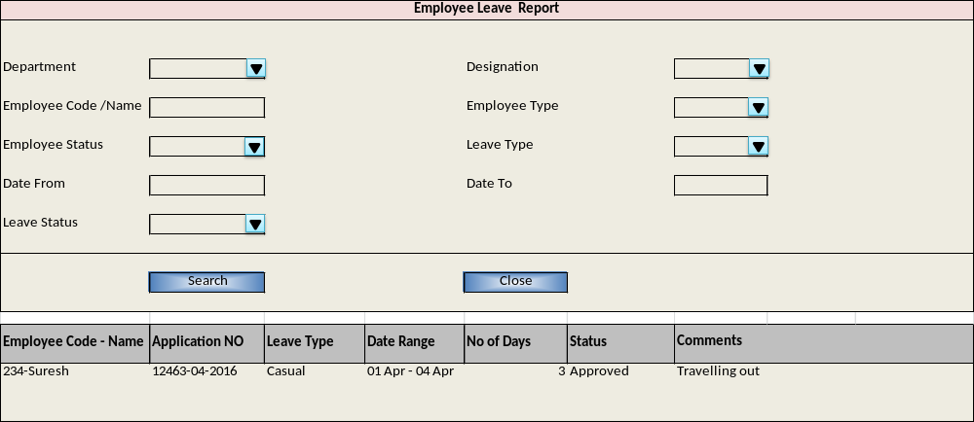

Field | Field Type | Required (Y/N) | Comments
Department | Select List | N | From Department master
Designation | Select List | N | From Designation master
Employee Code/Name | Text | N | Auto complete of employee code/name
Employee Status | Select List | N | From Status master – search will list employees with selected status
Employee Type | Select List | N | From Type master – search will list employees with selected type
Leave Type | Select List | N | List of leave types for master.
Date Range | Date | N | Date From and To for searching leaves with in the dates specified
Leave Status | Select List | N | List of leave status to search based on status
Note : Any one of the search criteria is mandatory
Search Details
Employee Code - Name | Display | Y | List of employee code-names based on the search criteria
Application No | Display | Y | Application number of the leave application
Leave Type | Display | Y | The leave type of the leave application
Date Range | Display | Y | Date or range of dates between which the leave was applied
No of Days | Display | Y | The number of days of leaves for the date/Range given. This should be based on the configuration flag which is defined to consider enclosed holiday on leave application.
Status | Display | Y | The current status of the leave application.
Comments | Display | N | The remarks given in the leave application.

Employee Leave Summary Report

Employees leave report shows the summary of leaves availed and available by leave type for each employee as of a given date. The report will allow user to sort by any of the fields displayed in the search result.

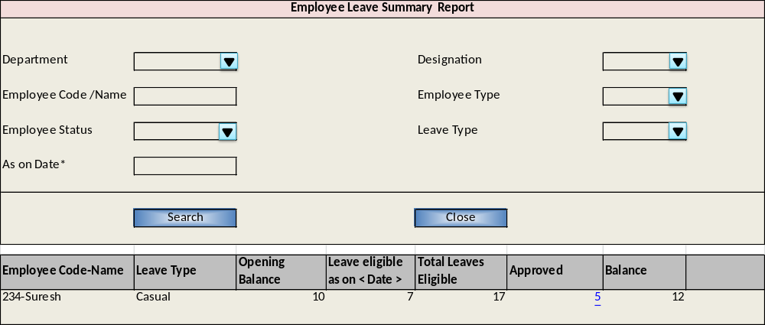

Field | Field Type | Required (Y/N) | Comments
Department | Select List | N | From Department master
Designation | Select List | N | From Designation master
Employee Code/Name | Text | N | Auto complete of employee code/name
Employee Status | Select List | N | From Status master – search will list employees with selected status
Employee Type | Select List | N | From Type master – search will list employees with selected type
Leave Type | Select List | N | List of leave types for master.
As on Date | Date | Y | Date as of which the report is to be generated
Note : Any one of the search criteria is mandatory along with “As on Date”
Search Details
Employee Code-Name | NA | NA | List of employee code-names based on the search criteria
Leave Type | NA | NA | Type of leave for which the leave summary is displayed for an employee.
Opening Balance | NA | NA | The opening balance for the leave type of the employee for the calendar year. This year is taken from the given date.
Leave eligible as on < Date > | NA | NA | The number leaves that employee is eligible as of the given date for the leave type. This should be pro-rated accordingly based on the date given.
Total Leaves Eligible | NA | NA | Total of opening balance and leave eligible.
Approved Leaves | Hyper link | NA | The total numbers of approved leaves applied by the employee for the given leave type till the date given.
Balance | NA | NA | The balance as of the given date : <Total-Availed>

From approved leave provide a drill down to show the employee leave report. It should list the approved leaves data for the employee and leave type respectively.

Employee without assignments

Employee without assignments displays all the employees who are not mapped to any assignment for the given date.

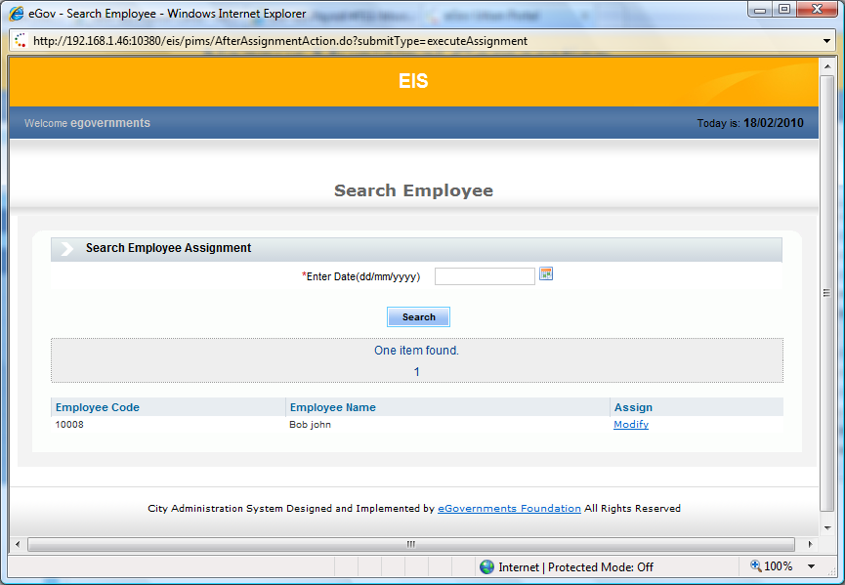

Field | Field Type | Required (Y/N) | Comments
Enter Date | Date | Y | Date for which the report is generated
Report details screen
Employee code | Display | Y | List of employee codes that do not have assignments for the given date. Hyper link to view the employee master.
Employee Name | Display | Y | Employee name Corresponding to the code

